INSTRUCTIONS FOR DAY CAMP REGISTRATIONS
LOG ON TO THE COUNCIL WEBSITE –www.lvacbsa.org
CHOOSE “CAMP” ON THE BLUE TABS
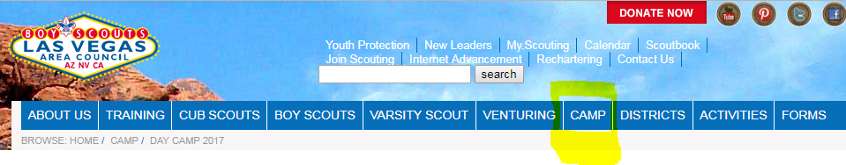
SCROLL DOWN TO DAY CAMP —then click on the BLUE register button
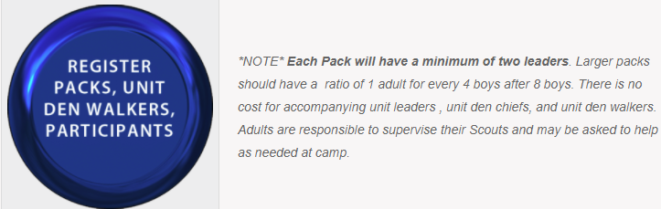

CHOOSE THE CAMP YOU WANT TO ATTEND

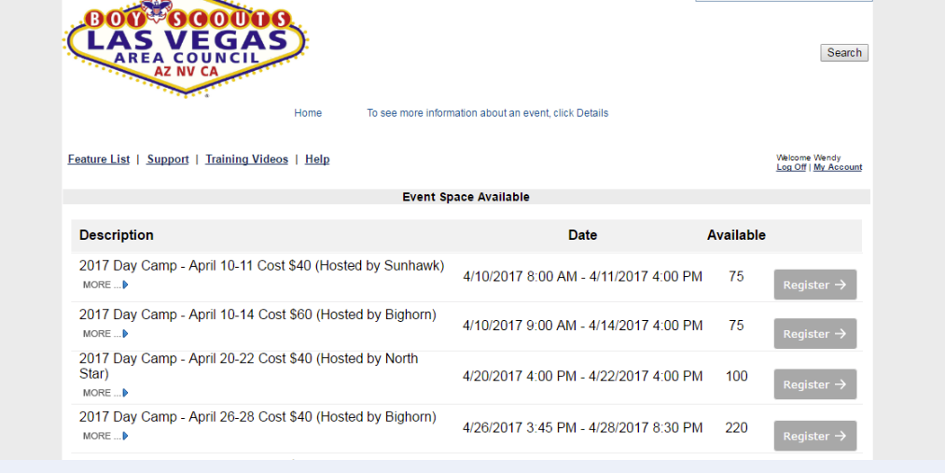

START BY CLICKING ON THE THE “REGISTER” BUTTON AT THE BOTTOM
Make sure to read and download necessary forms and directions on the “HERE” buttons on the main screen.
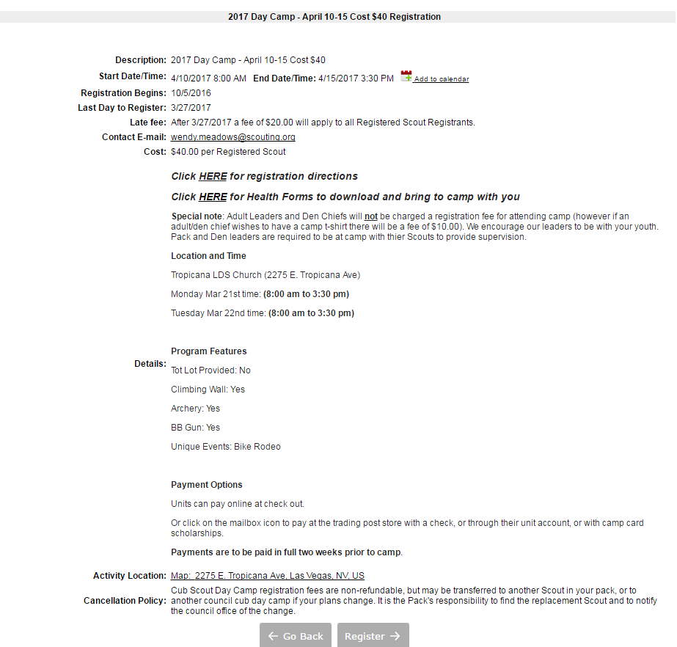

IF YOU DO NOT ALREADY HAVE A LOGIN “ID” AND PASSWORD FOR OUR ONLINE REGISTRATIONS (Double Knot) THEN YOU MUST CREATE ONE BY CLICKING ON “NEW GROUP”---IF YOU ALREADY HAVE A LOGIN -TYPE YOUR LAST NAME, SEARCH AND THEN SKIP THE NEXT STEP
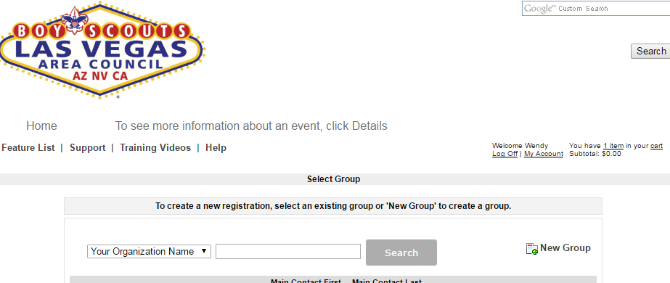
FILL IN ALL REQUIRED FIELDS BELOW AND CLICK “CONTINUE”
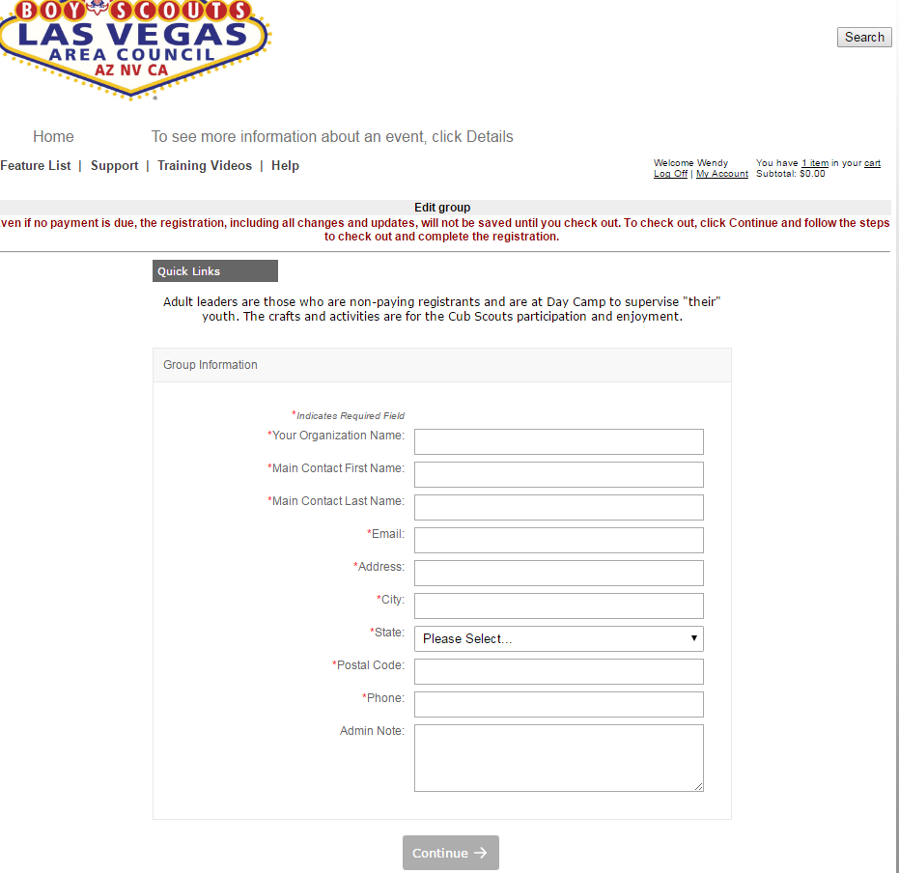
This will be the Pack number
ENTER HOW MANY SCOUTS, ADULTS, OR DEN CHIEFS WILL BE ATTENDING WITH YOUR UNIT.
Register attending adult Unit Leaders & Scouts and names for this event. Adults will need to add phone and emails.
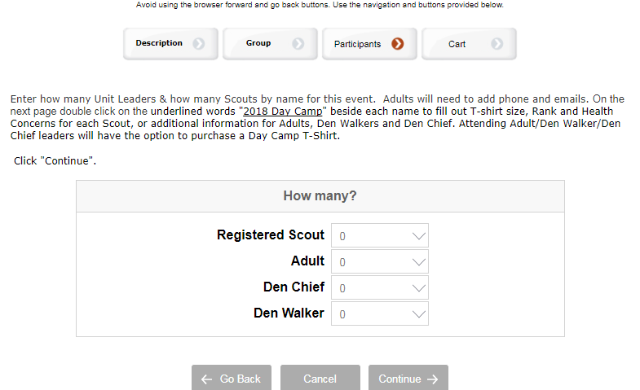
ADD NAMES OF EACH PARTICIPANT—ALL * are required fields
Click “Continue”
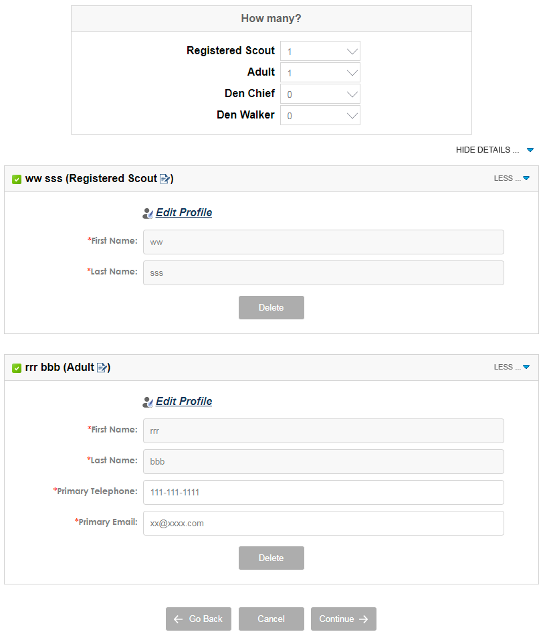
ADD INFORMATION FOR EACH PARTCIPANT
Click on the underlined words "Day Camp" beside each name to fill out T-shirt size, Rank and Health Concerns for each Scout, or additional information for Adult and Den Chief. Attending Adult/Den Chief leaders will have the option to purchase a Day Camp T-Shirt for a cost of $10.
Click "Continue".
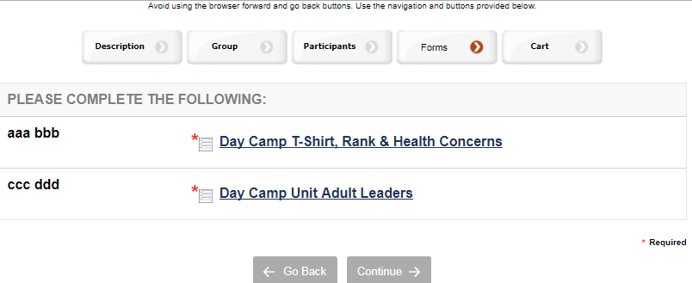
WHEN ALL INFORMATION IS CORRECTLY ENTERED THE “WHITE BOX” WILL HAVE A “GREEN CHECK MARK” ON IT -- Click "Continue".

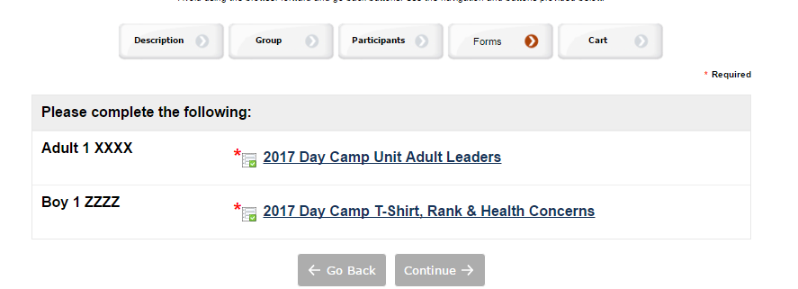

VERIFY AND CLICK “CHECKOUT”
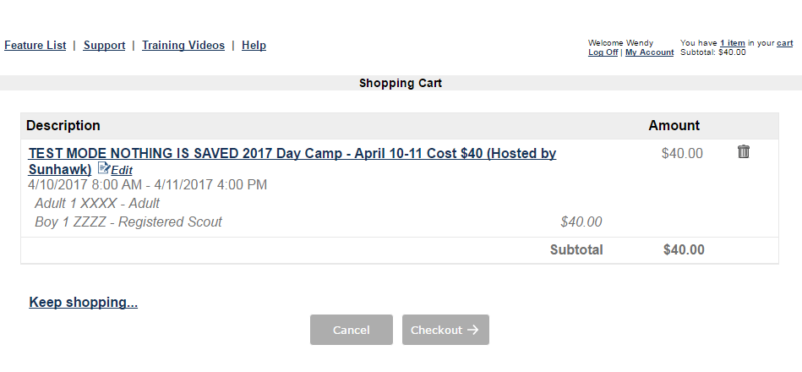

THE PAYMENT OPTION SCREEN POPS UP—CLICK ON THE FORM OF PAYMENT YOU WOULD LIKE (I.E VISA, AMERICAN EXPRESS …enter credit card info and click “MAKE A PAYMENT”). If you want to mail a check to the Scout Office just click on the “YELLOW MAILBOX” icon (for mailing a payment) ----Then click “COMPLETE ORDER”
